**Queue Management System**

By **The Brute Force -** When we all agree it’s the only way things can get done**.**

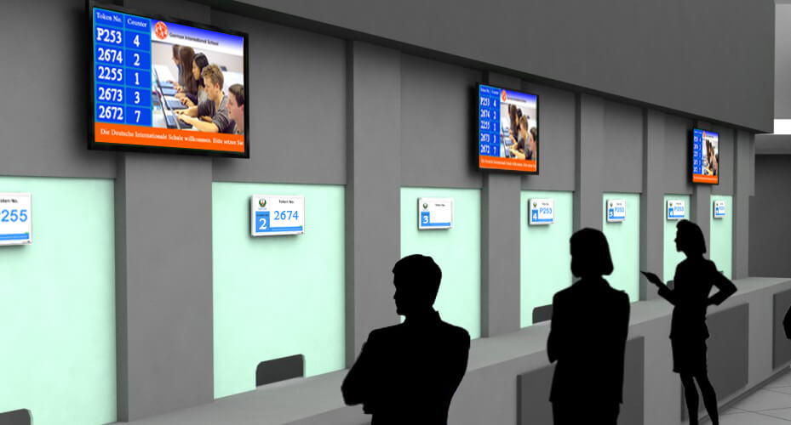**Abstract :** Queue Management System is a solution to the social difficulty(**S** in the **RISE**)We encounter many queueing systems in our day to day lives, from grocery stores to amusement parks they’re everywhere. There is a lot of randomness involved in these systems, which can cause huge delays, result in long queues, reduce efficiency, and even monetary loss. The randomness can be addressed by developing a discrete event simulation model, this can be extremely helpful in improving the operational efficiency, by analysing key performance measures.

**Introduction :**

In this project, we are going to be simulating a queueing system similar to a bank. We all have visited a bank at some point in our life, and we are familiar with how banks operate. Customers enter, wait in a queue for their number to be called out, get service from the teller, and finally leave. This rate of arrival is assumed in this case but should be modeled from actual data to get accurate results. They wait in a single line for an idle teller. This type of system is referred to as a M/M/2 queueing system. When a customer enters the bank and both tellers are idle, they choose either one with equal probabilities. If a customer enters the bank and there are four people waiting in the line, they will leave the bank with probability 50%. If a customer enters the bank and there are five or more people waiting in the line, they will leave the bank with probability 60%.

**System Requirements :**

* **Pandas :** Pandas were used to show the recorded data we we take from the system after every iteration.
* **Numpy :** Numpy was used to generate randomness in the system.We used it to generate a random arrival time,departure time ,no of customers and more
* **Tkinter :** tkinter was mainly used for the implementation of gui to the given system. It included buttons, labels,background images,dialog boxes etc.

**Flow chart :**

Lets try to visualize the system

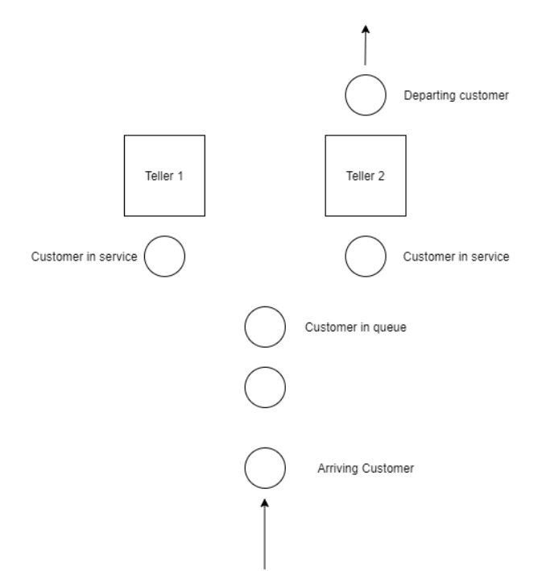

**Arrival :**

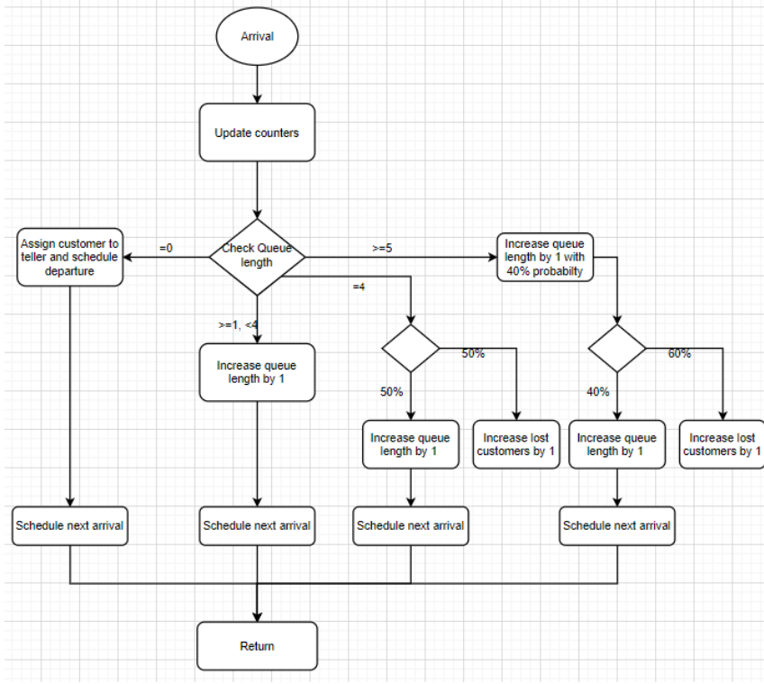**Departure :**

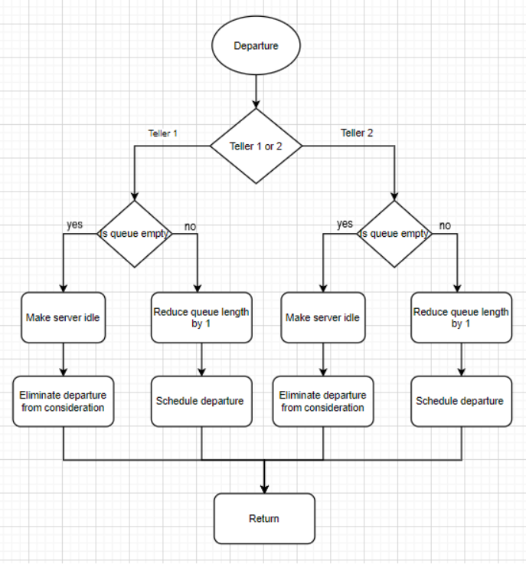

**Demonstration :**

The control flow of the program is shown in the below flowchart, Blue color boxes indicates choices or buttons. Orange color boxes gives the basic function at that step.

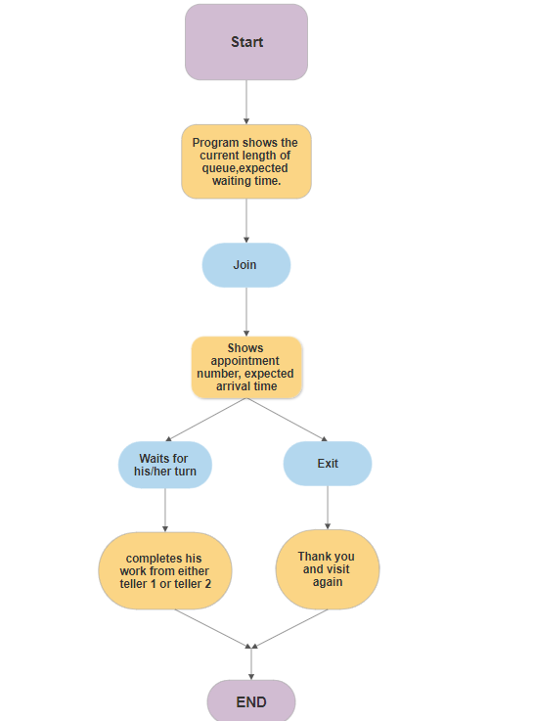

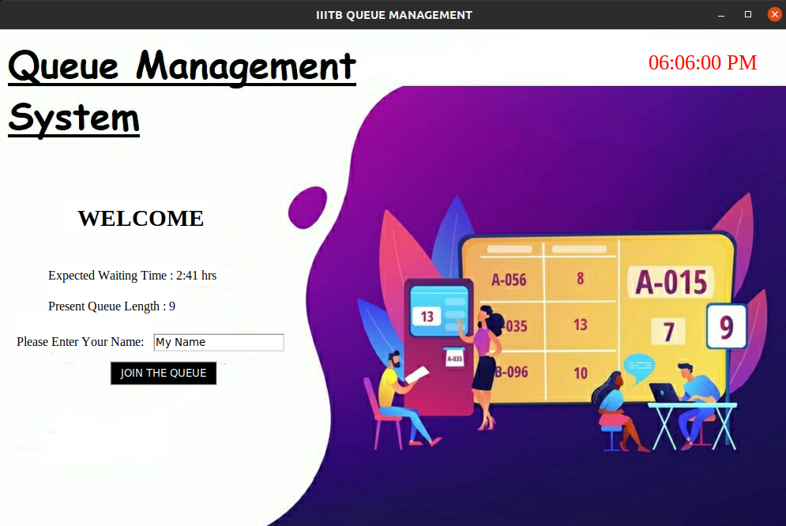

**The above screen is visible to the user at the beginning..!!**

The customer can check the expected wait time per person and number of people present in queue already. The customer can therefore decide whether to join the queue to receive the service or not.

The customer should enter his/her name in entry given and hit the “JOIN THE QUEUE” button.

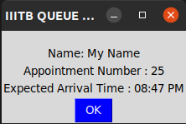

This will a window showing the customer’s name , appointment number and the expected time , when he/she can avail the service.

**Then comes the CANCELLATION window :(**

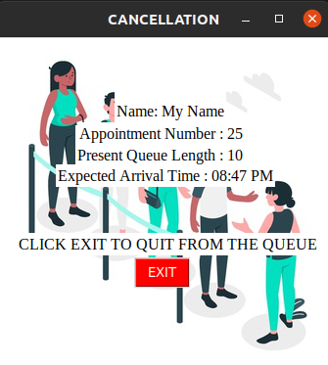The cancellation window will display the customer’s name his/her appointment number ,present queue length and expected arrival time.

An “EXIT” button will get display,which on pressing removes the customer from the queue and the last window gets popped that thanks the customer .  
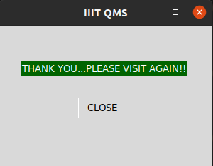

**Future Aspects :**

1. We can convert it into reception oriented queue management system.
2. We can include features like queues based on priority.
3. We can also include SMS texts as a method of customer communication.

**References :**

* <https://en.wikipedia.org/wiki/Discrete-event_simulation>
* https://en.wikipedia.org/wiki/M/M/c_queue
* https://en.wikipedia.org/wiki/Queueing_theory
* https://numpy.org/
* https://pandas.pydata.org/
* https://docs.python.org/3/library/tkinter.html

**LINK TO GITHUB REPOSITORY**

https://github.com/born2win685/QUEUE-MANAGEMENT-SYSTEM